REST - Country Web Service
Scenario: Write a REST service in the Spring Learn application that returns India country details. The service exposes a GET endpoint at /country, implemented in the CountryController class, and loads the India bean from a Spring XML configuration file to build the JSON response.

What Was Done
• Created a Country model class with code and name fields, along with getters and setters.
• Created applicationContext.xml under src/main/resources defining an 'india' bean with code set to IN and name set to India.
• Created the CountryController class inside the controller package.
• Implemented the getCountryIndia() method mapped to /country using @RequestMapping, which loads the Spring XML configuration and retrieves the india bean.
• Added SLF4J logger statements at the start and end of the getCountryIndia() method.
• Ran the Spring Boot application and confirmed Tomcat started successfully on port 8083.
• Verified the endpoint in Chrome browser and checked the response headers using Chrome DevTools Network tab.
• Verified the endpoint in Postman and checked the response headers using the Headers tab.

Result
The REST service was created and tested successfully. Hitting http://localhost:8083/country in both Chrome and Postman returned the expected JSON response {"code":"IN","name":"India"} with HTTP status 200 OK. The application console confirmed the start and end log messages were printed on every request.

SME Explanation
• What happens in the controller method: When a GET request hits /country, Spring invokes getCountryIndia(). Inside the method, a ClassPathXmlApplicationContext is created from applicationContext.xml, and the india bean is fetched from it using getBean(). This bean is a fully populated Country object with code IN and name India, which is then returned from the method.
• How the bean is converted into a JSON response: Since CountryController is annotated with @RestController, Spring automatically uses its built-in Jackson library to serialize the returned Country object into JSON. Jackson inspects the object's getter methods (getCode() and getName()) and maps them to JSON keys code and name, producing the final response body.

Country Model Class
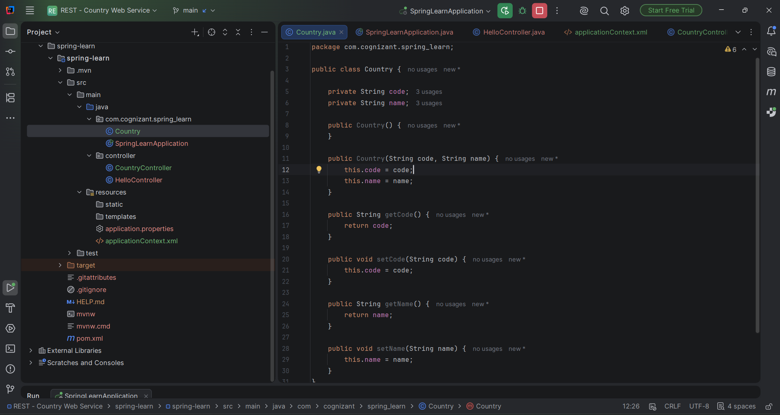
Figure 1: Country.java defining the code and name fields with a parameterized constructor, getters, and setters.

applicationContext.xml Configuration
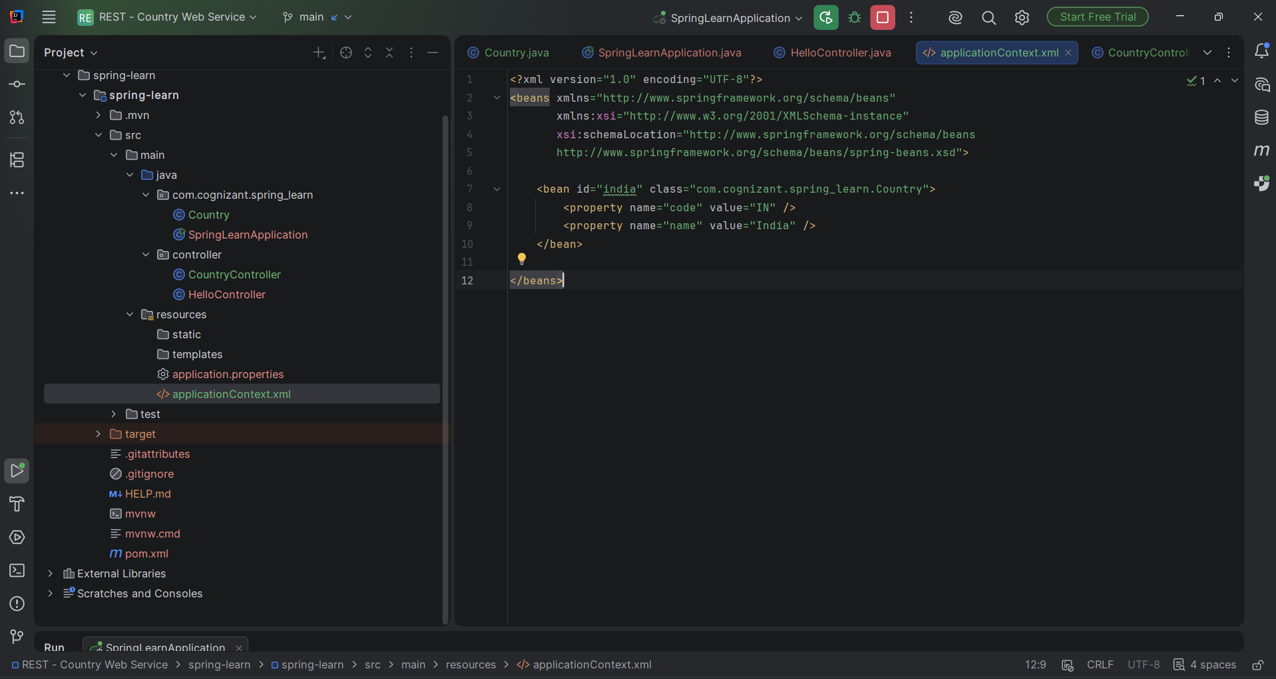
Figure 2: applicationContext.xml defining the india bean with code=IN and name=India.

CountryController Implementation
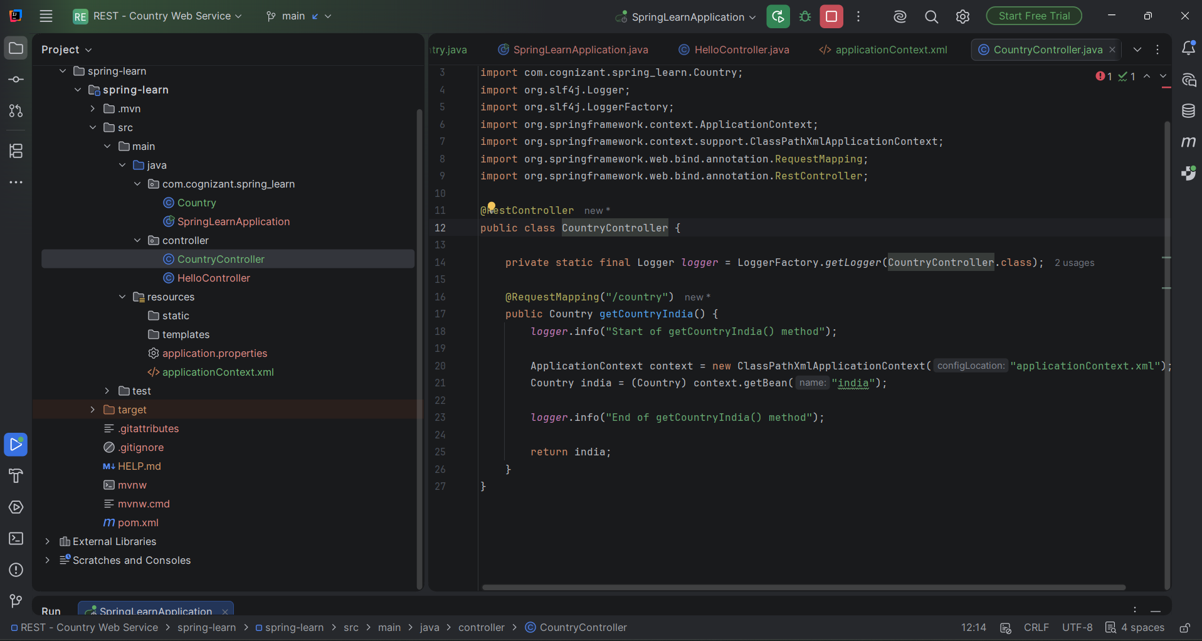
Figure 3: CountryController.java with getCountryIndia() method, @RequestMapping for /country, and start/end log statements.

Application Console Logs
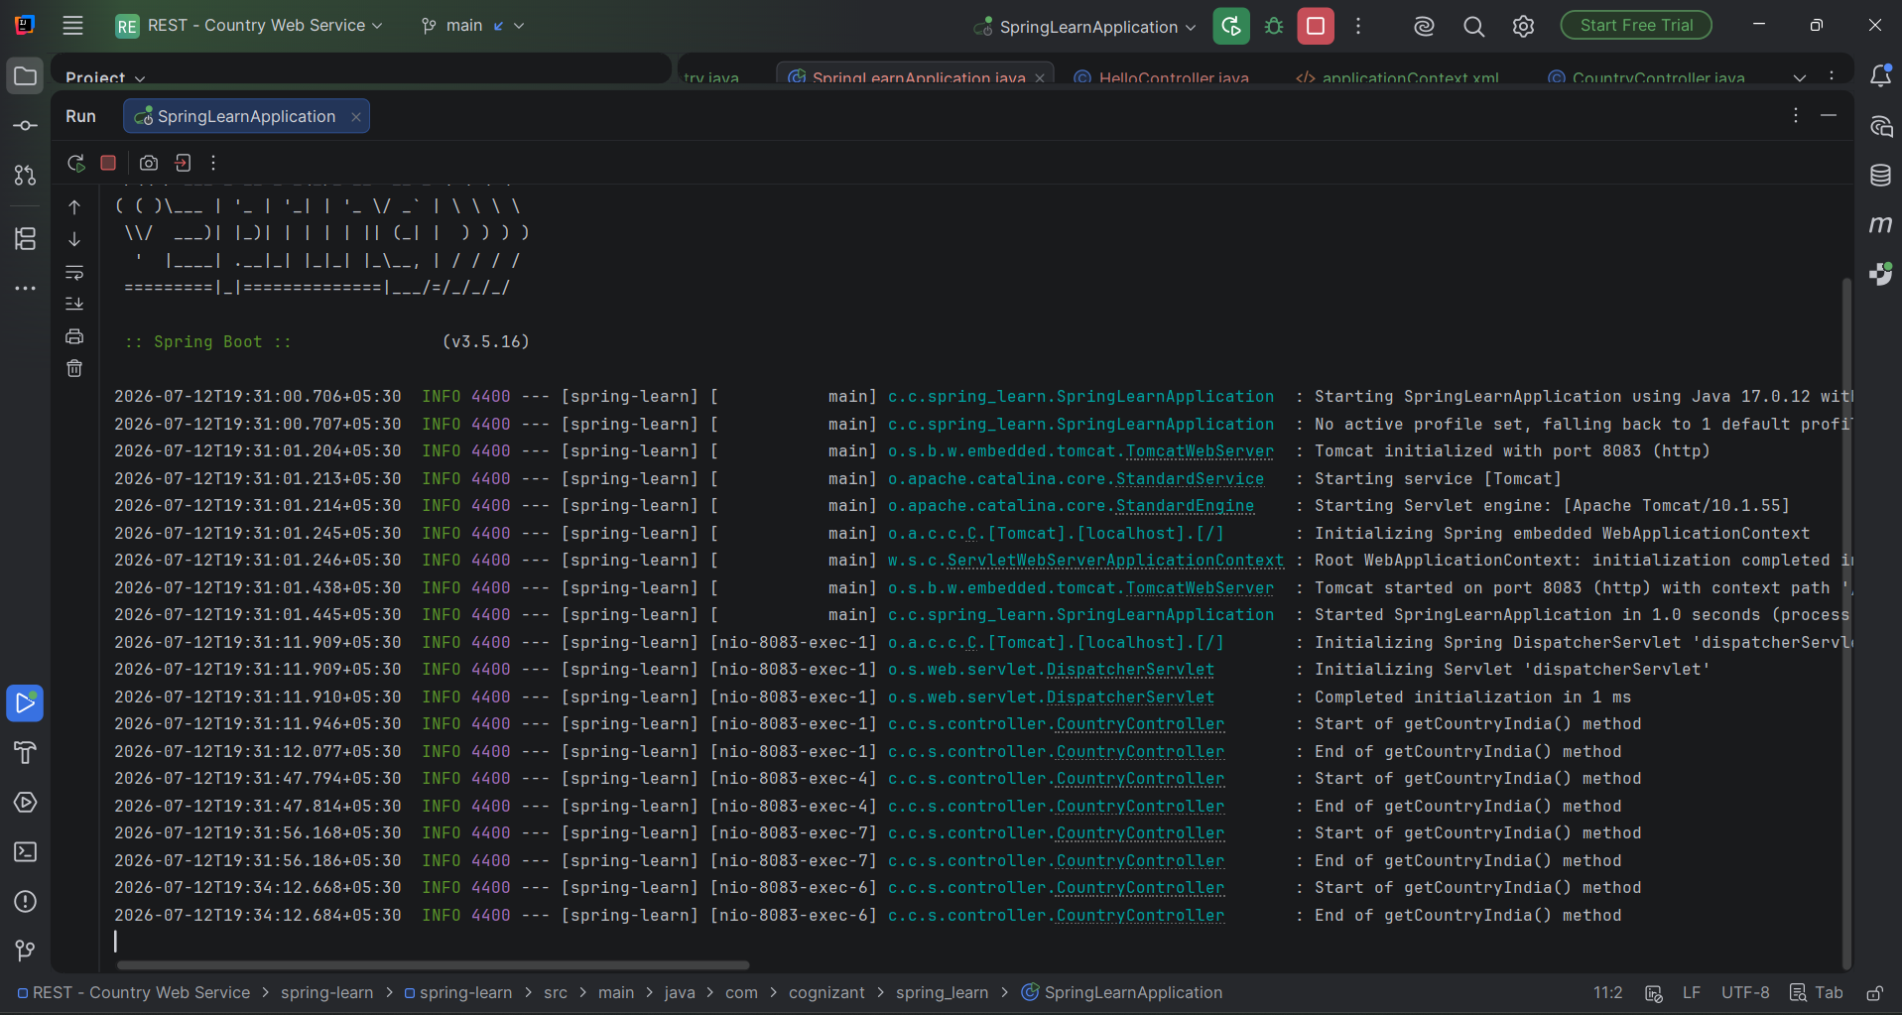
Figure 4: Console output showing Tomcat started on port 8083 and repeated Start/End of getCountryIndia() log entries for each request.

Testing in Chrome Browser
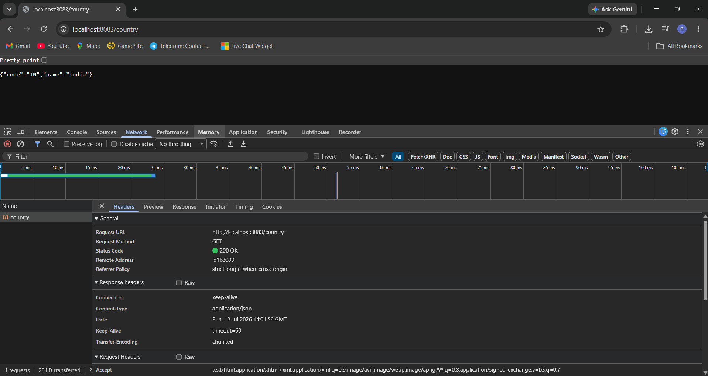
Figure 5: Chrome browser displaying the JSON response and DevTools Network tab showing response headers, including Content-Type as application/json.

Testing in Postman - Response Body
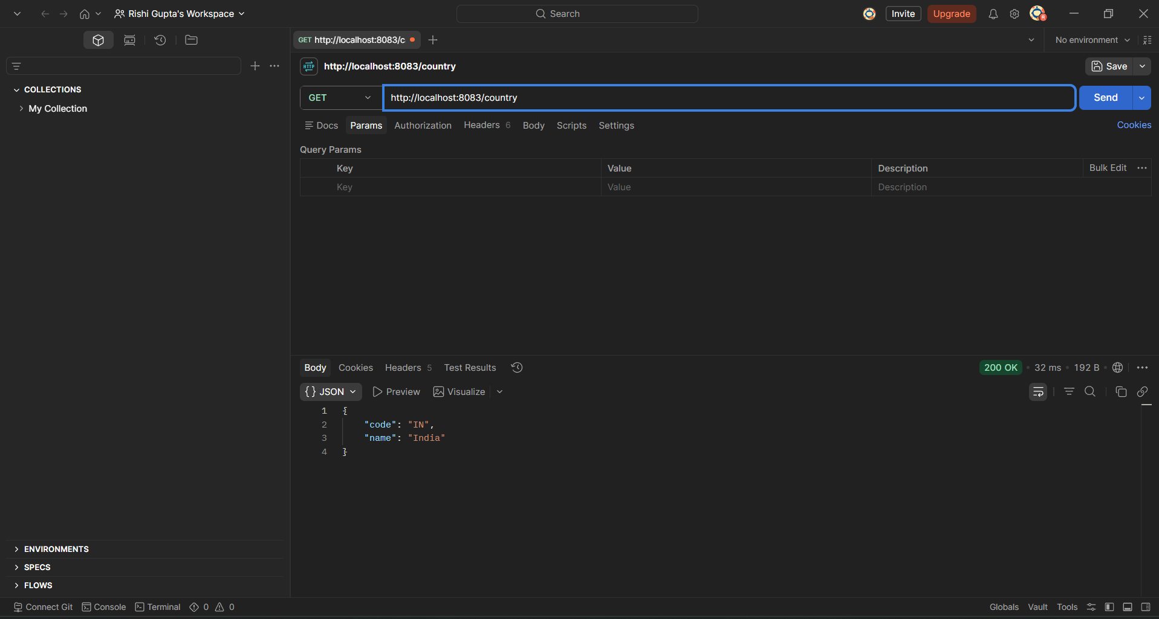
Figure 6: Postman GET request to http://localhost:8083/country returning status 200 OK with the JSON body.

Testing in Postman - Response Headers
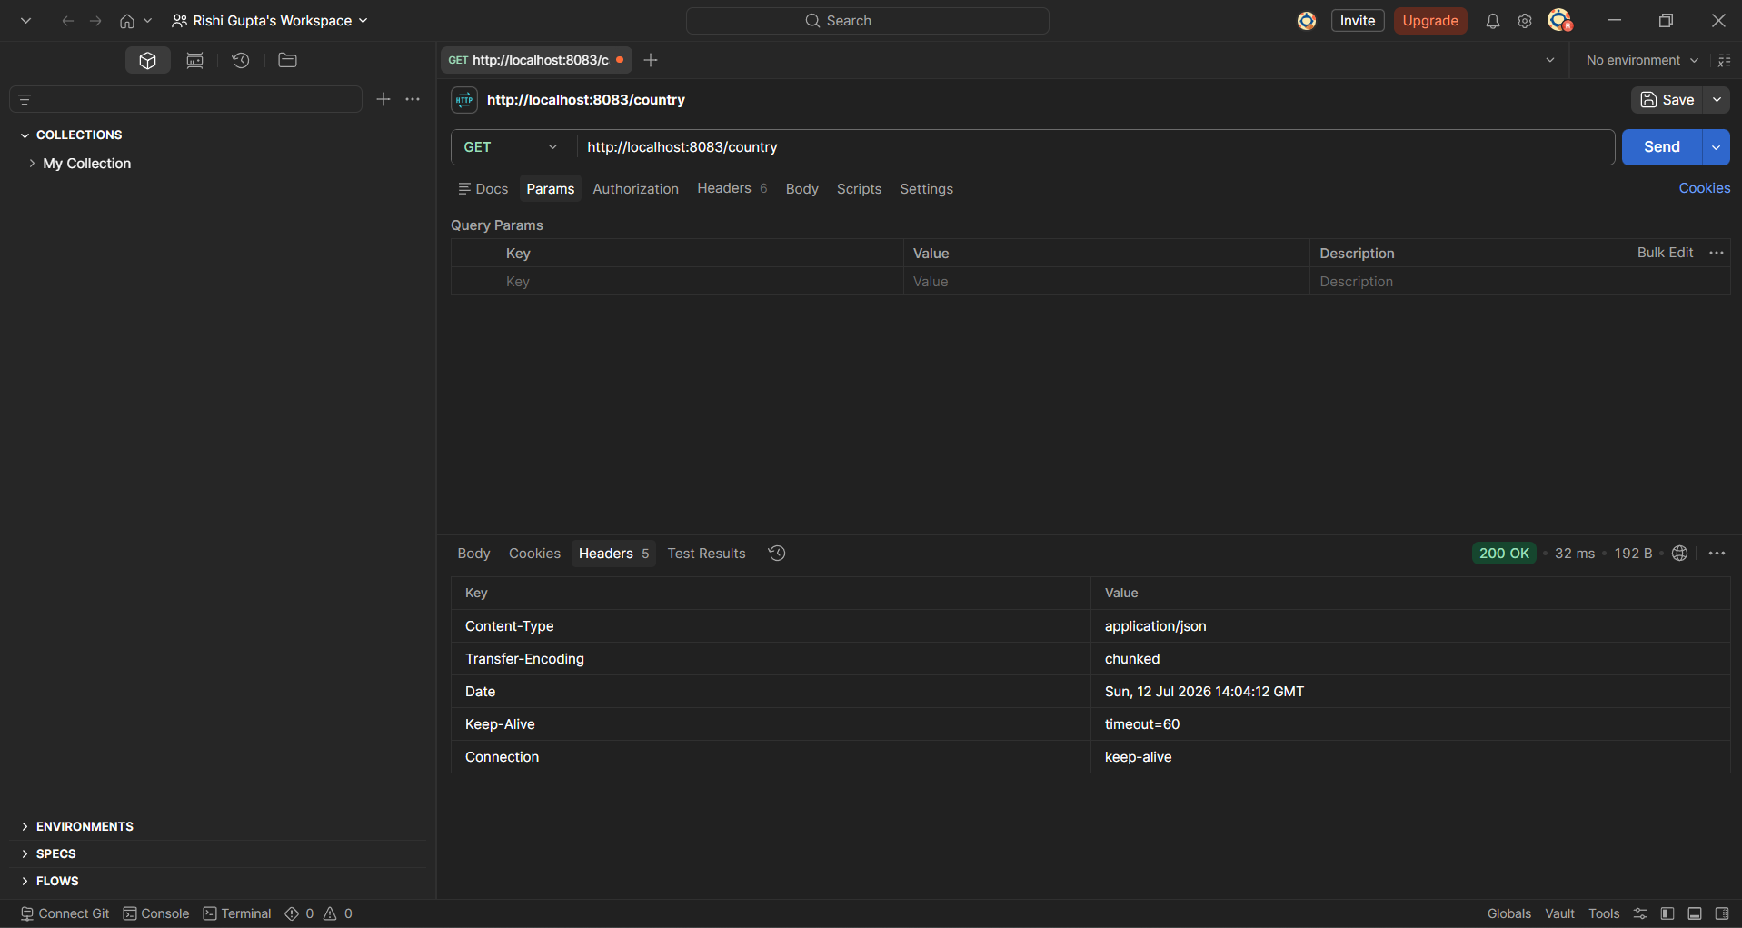
Figure 7: Postman Headers tab showing response headers received from the server.

